**GENERAL KNOWLEDGE LESSON GUIDE**

**FOR BABY CLASS (3 – 4YRS) TERM THREE 20223**

**WEEK 1 ORIENTATION WEEK**

WK2

**PD 1** **God’s creation**

**Activities**

* Singing
* Rhyming
* Recognition
* 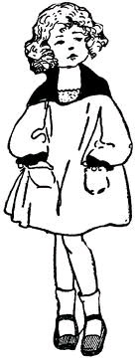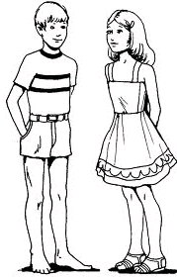Naming things made by God orally

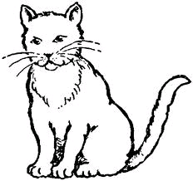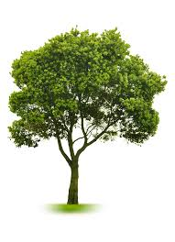

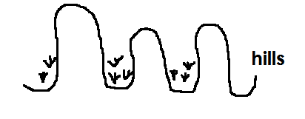

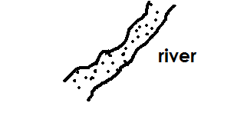

**PD II** **God’s creation**

**Activities**

* Singing
* Recognition
* Naming
* Drawing
* D:\New Folder\PECC Stem pictures\stone.bmpMatching



D:\New Folder\PECC Stem pictures\stone.bmp

**PD IV** God’s creation

**Activities**

* Reciting rhymes
* Identification
* Naming things created by God
* Drawing
* Blending and reading
* Copy and learn

|  |  |  |  |
| --- | --- | --- | --- |
| sun | https://encrypted-tbn0.gstatic.com/images?q=tbn:ANd9GcRWKIbNTkHzXmw9vwsybpOj-zRLr0AdlE53K8SRbUlwsNDyYq2_oQ  tree | moon | cat |
|  |  |  |  |

**WEEK 3**

**PD 1** God’s creation

**Activities**

* Singing
* Naming
* Drawing
* Blending and reading
* Matching

cat



sun

tree



moon

**WEEK 3**

**PD II**  **Our home**

**Activities**

* Singing
* Recognition
* Naming people found at home orally
* Drawing





**PD III** **Our home**

**Activities**

* Singing
* Recognition
* Naming people at home e.g. father , mother , sister , brother
* Drawing
* Spelling , blending and reading
* 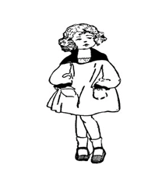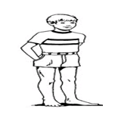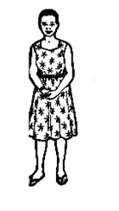Copy and learn

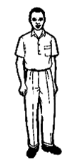

father mother brother sister

**PD IV** **Our home**

**Activities**

* Identifying people found at home
* Naming
* Blending and reading
* Read and match

father

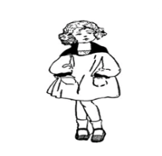

sister



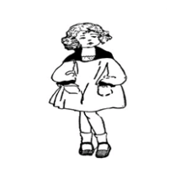 mother

brother

**WEEK 4**

**PD 1** **Things found at home**

**Activities**

* Recognition
* Naming
* Drawing
* Blending and reading
* Copy and learn

|  |  |  |  |
| --- | --- | --- | --- |
| cup | bed | jug | pot |
|  |  |  |  |

**WEEK 4**

**PD III** **Things found at home**

**Activities**

* Drawing
* Recognition
* Naming pictures

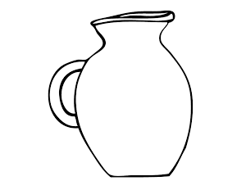

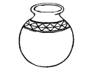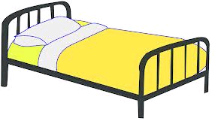

( jug , bed , cup , pot)

**PD IV** **Parts of the body**

**Activities**

* Singing
* Reciting rhymes
* Naming
* 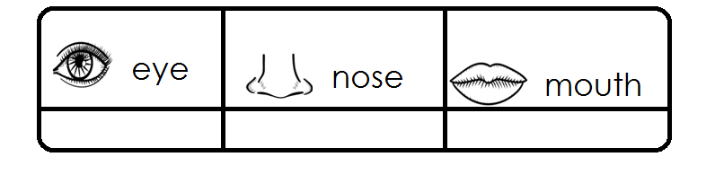Copy and learn

**WEEK 5**

**PD I** **Parts of the body**

**Activities**

* Singing
* Naming
* Recognition
* 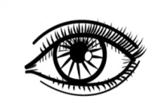Matching

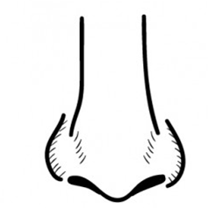ear

mouth

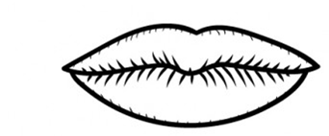 eye

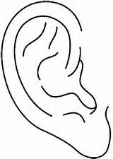 leg

nose

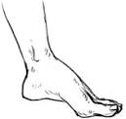

**PD II** **Parts of the body**

**Activities**

* Singing
* Identification
* Listening
* Speaking
* Blending and reading
* 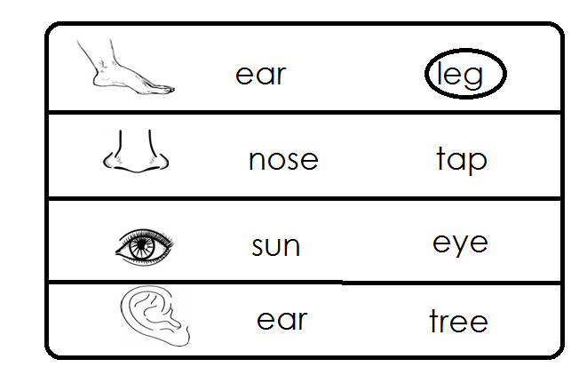Circling the word for the picture

**WEEK 5**

**PD III** **Things used to clean the body**

**Activities**

* Singing
* Recognition
* Naming things used to clean the body
* Drawing
* Copy and draw

|  |  |  |  |
| --- | --- | --- | --- |
| [http://t0.gstatic.com/images?q=tbn:ANd9GcSuy8S_Lzt-68Wd6soOdMJe2TeVREoDQDpkHYVPdopIBbUZl7UTzjA4jZCGUA](http://www.google.co.ug/imgres?imgurl=http://etc.usf.edu/clipart/19100/19127/soap_19127_lg.gif&imgrefurl=http://etc.usf.edu/clipart/19100/19127/soap_19127.htm&usg=__X2zEXi_NshsM831SBoX1qtRosa4=&h=663&w=700&sz=48&hl=en&start=20&zoom=1&tbnid=kjnNfH9gkO-xyM:&tbnh=133&tbnw=140&ei=HJa2TbyWB8ftOaXSwP4O&prev=/search?q=soap&hl=en&sa=N&gbv=2&tbm=isch&itbs=1) |  |  |  |
|  |  |  |  |

**PD IV** **Things used to clean the body**

**Activities**

* Singing
* Rhyming
* Naming
* Drawing
* [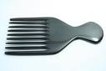](http://www.google.co.ug/imgres?imgurl=http://indianbuffalohorn.com/yahoo_site_admin1/assets/images/horn_comb.161172658.jpg&imgrefurl=http://www.indianbuffalohorn.com/horn_combsmassage_tools&usg=__3voE9SBBds7xg4tjv2OVFYnl7ak=&h=300&w=450&sz=11&hl=en&start=93&zoom=1&tbnid=6S_y9dVQgqZNLM:&tbnh=85&tbnw=127&ei=qJa2TaLDOMmXOsjD4P0O&prev=/search?q=comb&start=80&hl=en&sa=N&gbv=2&tbm=isch&itbs=1)Matching

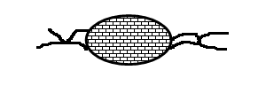

[](http://www.google.co.ug/imgres?imgurl=http://indianbuffalohorn.com/yahoo_site_admin1/assets/images/horn_comb.161172658.jpg&imgrefurl=http://www.indianbuffalohorn.com/horn_combsmassage_tools&usg=__3voE9SBBds7xg4tjv2OVFYnl7ak=&h=300&w=450&sz=11&hl=en&start=93&zoom=1&tbnid=6S_y9dVQgqZNLM:&tbnh=85&tbnw=127&ei=qJa2TaLDOMmXOsjD4P0O&prev=/search?q=comb&start=80&hl=en&sa=N&gbv=2&tbm=isch&itbs=1)

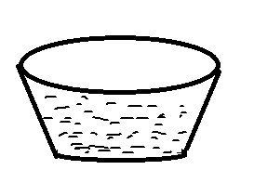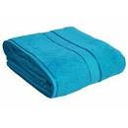

[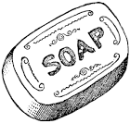](http://www.google.co.ug/imgres?imgurl=http://etc.usf.edu/clipart/19100/19127/soap_19127_lg.gif&imgrefurl=http://etc.usf.edu/clipart/19100/19127/soap_19127.htm&usg=__X2zEXi_NshsM831SBoX1qtRosa4=&h=663&w=700&sz=48&hl=en&start=20&zoom=1&tbnid=kjnNfH9gkO-xyM:&tbnh=133&tbnw=140&ei=HJa2TbyWB8ftOaXSwP4O&prev=/search?q=soap&hl=en&sa=N&gbv=2&tbm=isch&itbs=1)



**WEEK 6**

**PD I** **Things use to clean the body**

**Activities**

* Recognition
* Naming
* Blending and reading
* Copy and learn

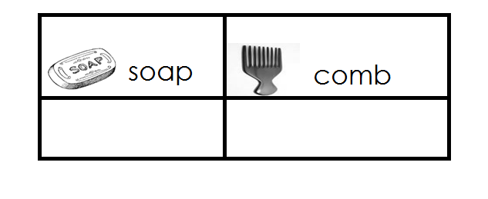

**PD II** **Things used to clean the body**

**Activities**

* Identification and naming
* Spelling and reading
* Drawing
* Naming
* Copy and learn

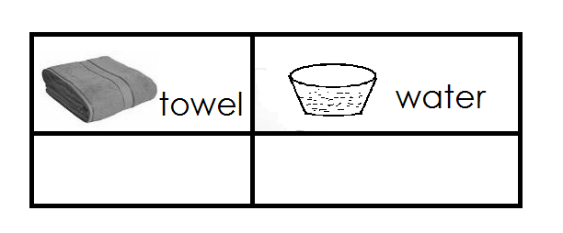

**WEEK 9**

**PD III** **Things used to clean the body**

**Activities**

* Recognition
* Naming
* Blending and reading
* Matching

[](http://www.google.co.ug/imgres?imgurl=http://etc.usf.edu/clipart/19100/19127/soap_19127_lg.gif&imgrefurl=http://etc.usf.edu/clipart/19100/19127/soap_19127.htm&usg=__X2zEXi_NshsM831SBoX1qtRosa4=&h=663&w=700&sz=48&hl=en&start=20&zoom=1&tbnid=kjnNfH9gkO-xyM:&tbnh=133&tbnw=140&ei=HJa2TbyWB8ftOaXSwP4O&prev=/search?q=soap&hl=en&sa=N&gbv=2&tbm=isch&itbs=1)

comb



water



soap

[](http://www.google.co.ug/imgres?imgurl=http://indianbuffalohorn.com/yahoo_site_admin1/assets/images/horn_comb.161172658.jpg&imgrefurl=http://www.indianbuffalohorn.com/horn_combsmassage_tools&usg=__3voE9SBBds7xg4tjv2OVFYnl7ak=&h=300&w=450&sz=11&hl=en&start=93&zoom=1&tbnid=6S_y9dVQgqZNLM:&tbnh=85&tbnw=127&ei=qJa2TaLDOMmXOsjD4P0O&prev=/search?q=comb&start=80&hl=en&sa=N&gbv=2&tbm=isch&itbs=1)

towel

**PD IV** **Important places**

**Activities**

* Recognition
* Naming
* Drawing
* Copy and learn

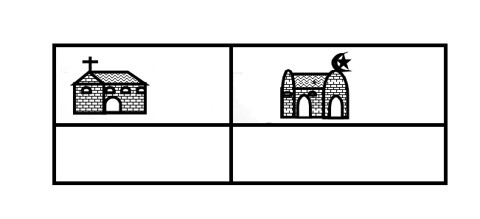

**WEEK 7**

**PD 1** **Important places**

**Activities**

* Identification
* Naming
* Drawing
* Copy and learn

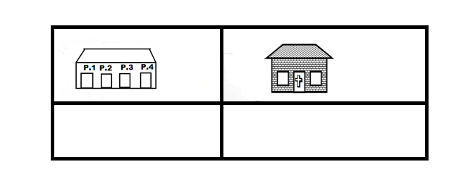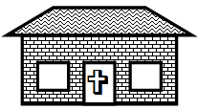

**PD II**  **Important places**

**Activities**

* Singing
* Reading
* Naming
* Copy and learn

**PD III** **Important places**

**Activities**

* Recognition
* Naming
* Drawing
* Copy and learn

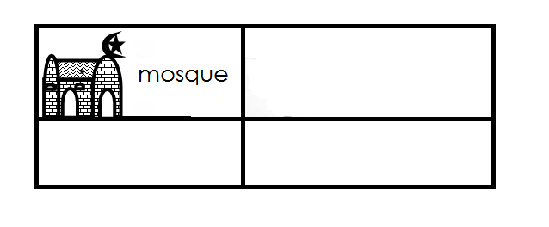

**PD IV** **Important places**

**Activities**

* Identification
* Naming
* Spelling and reading
* Drawing
* 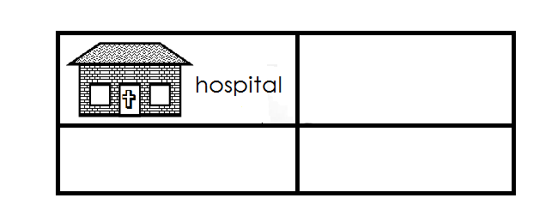Copy and learn

**WEEK 8**

**PD 1** **Important places**

**Activities**

* Recognition
* Naming
* Blending and reading
* 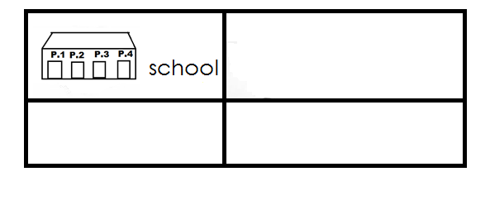Copy and learn

**PD II** **People found at important places** ( important people)

**Activities**

- Recognition

- Listening

- Speaking

- Naming important people orally

doctor nurse

teacher imam

priest sheik

policeman police woman

farmer barber

**PD III** **Important people and their work places**

**Activities**

- Recognition

- Naming

- Spelling and reading orally

**Important people Role**

Priest preaches the word of God in a church

teacher teaches children

doctor treats sick people

nurse takes care of sick people

farmer grows crops and keeps animals

barber cuts people’s hair

Imam / sheik preaches in a mosque

**PD IV** **Important people and their roles**

**Activities**

- Recognition

- Naming

- blending and reading orally

**People**  **Place of work**

- Priest - church

- doctor / nurse - hospital

- teacher - school

- barber - Barber’s shop

- Imam / Sheik - Mosque

- Police man / woman - Police station